Title : Script-Controlled ACL – Restrict
Record Access Based on Field Value
College Name : Balagan Saraswathi Arts and Science
College for Women
College Code : MSU144
University Name : Manonmaniam Sundaranar University
Tirunelveli
Course Name : ServiceNow – System Admin with IT Service
Management & AI Emphasis
Team ID | : SWTID-2026-3161
Team Leader | : Muthu Iswarya C
Team member | : a Sowmya S
Team member | : Dharshini M
Team member | : Esakiammal A

Script-Controlled ACL – Restrict Record Access Based on Field Value
Introduction:
This lab demonstrates how to implement a script-controlled Access Control List (ACL) to restrict users from viewing records unless they meet specific conditions. In this scenario, only users belonging to the EEE branch are allowed to view records where the Branch field is set to EEE, while administrators retain full access. Milestone-1 Creation of Users and Roles
User Creation:
- Log in to the ServiceNow instance with admin access.
- Create a test user:
  - Navigate to User Administration → Users
  - Click New o User ID: EEE User o First name: EEE o Last name: User o Email: eeeuser@gmail.com o Save the record

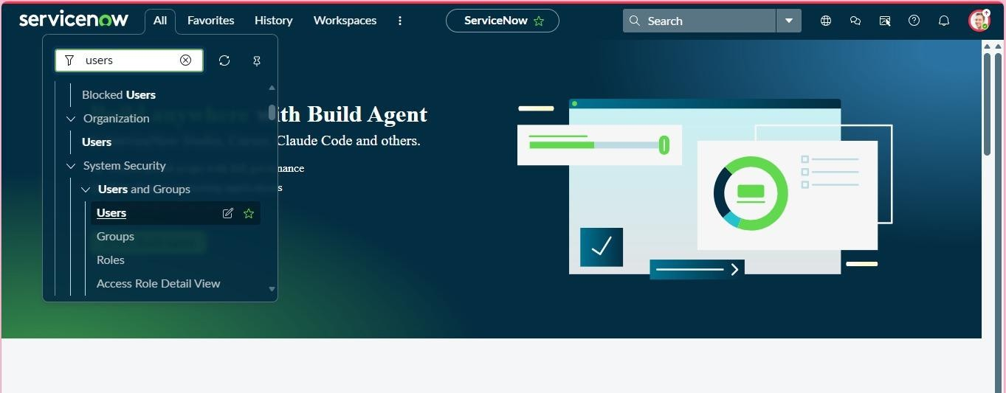
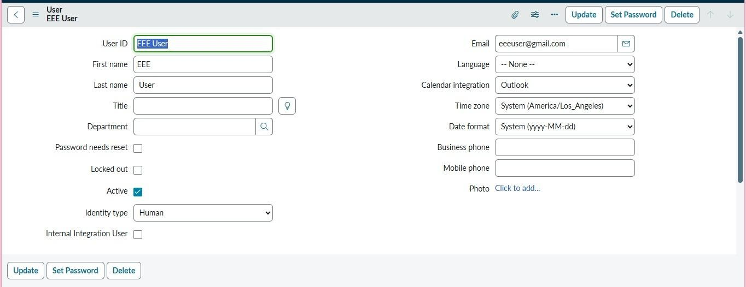
Role Creation
  - Navigate to User Administration → Roles
  - Click New
  - Name: Enter role name as bb1
  - Description: Brief role purpose
  - Click Submit
  - Create other roles also like bb2,bb3,bb4.(follow the same procedure) • Assign all the roles to the EEE User

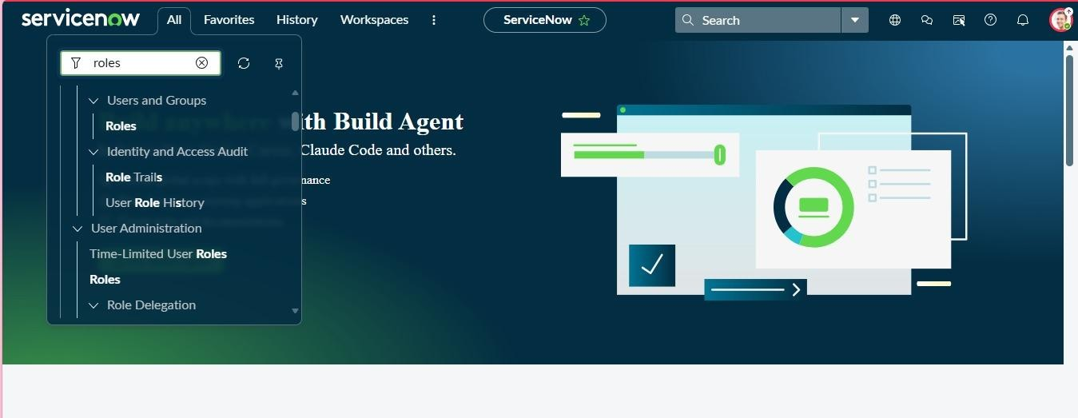

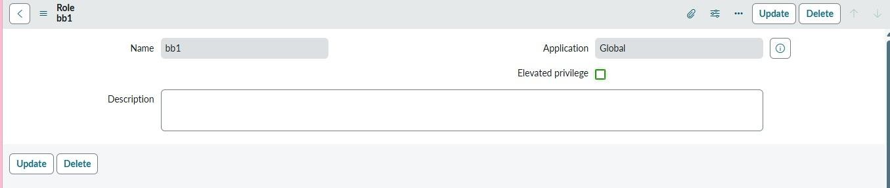

Tables Creation
- In the Application Navigator, search for System Definition → Tables.
- Click New and create a custom table with the following details:
  - Label: Institution Details o Name: u_institution_details o Extends for : false
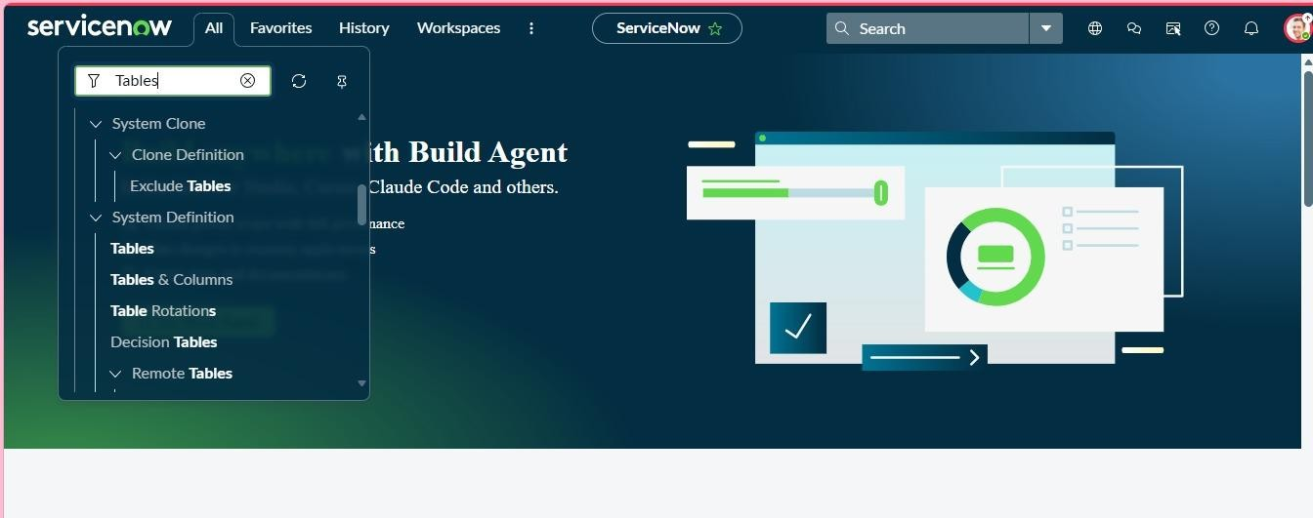
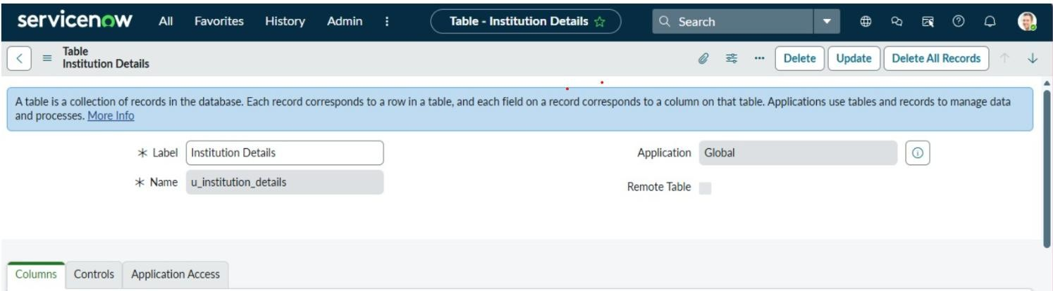
- Click Submit.
- Add the following fields to the u_institution_details table:
  - Student Roll Number– Auto Number o Student Name – Reference- User o Faculty Name – Reference- User o Branch – Choice (ECE, EEE, CSE) o Email– String o Phone Number– String o Description– Multi String
- Save the Table
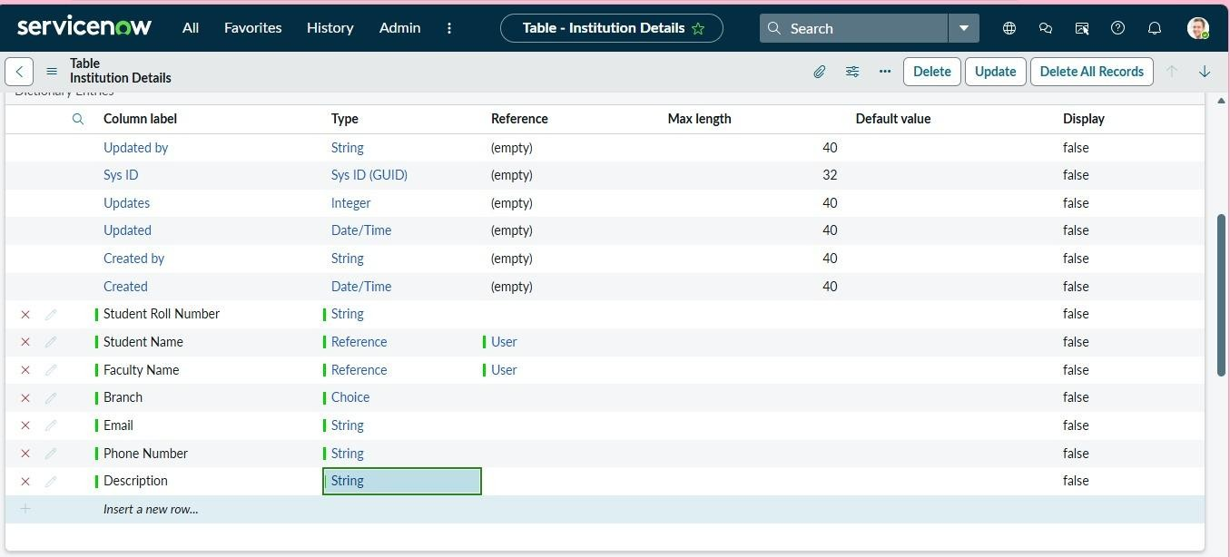
- Create multiple records in the Student Records table with different branch values (ECE, EEE, CSE).
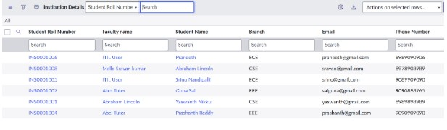

Creation of Access Control Lists(Read ACL)
- In the Application Navigator, search for System Security → Access Control (ACL).
- Elevate “Security_admin” role 3. Click New to create a new ACL.
- Enter the following details:
  - Type: record o Operation: read o Name: u_institution_details o Active: true o Advanced: true
- In the Requires role related list, add:
  - bb1 (custom role)
- Add Data condition as Branch is EEE

- In the Script field, add the following script:
(function () {
// Allow admin users full access if (gs.hasRole('admin')) {
return true;
}
// Allow only EEE branch users to see EEE records if (gs.hasRole('bb1')){
return true;
}
// Deny access for all others
return false;
})();

- Click Submit to save the ACL.
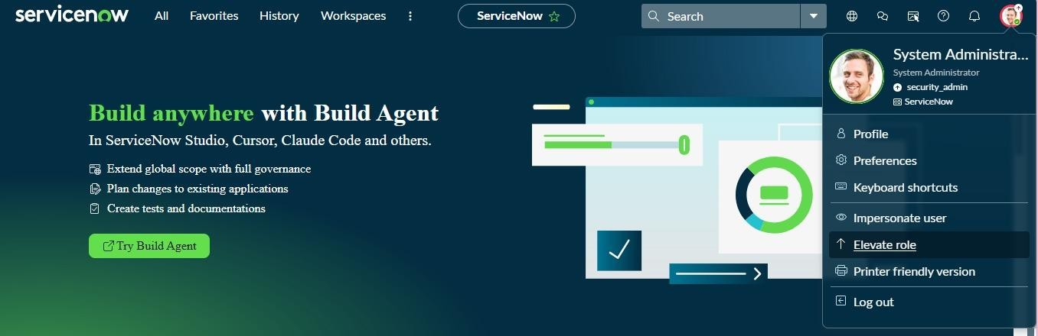

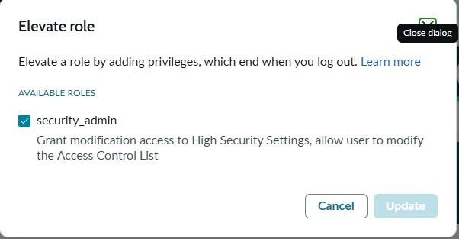

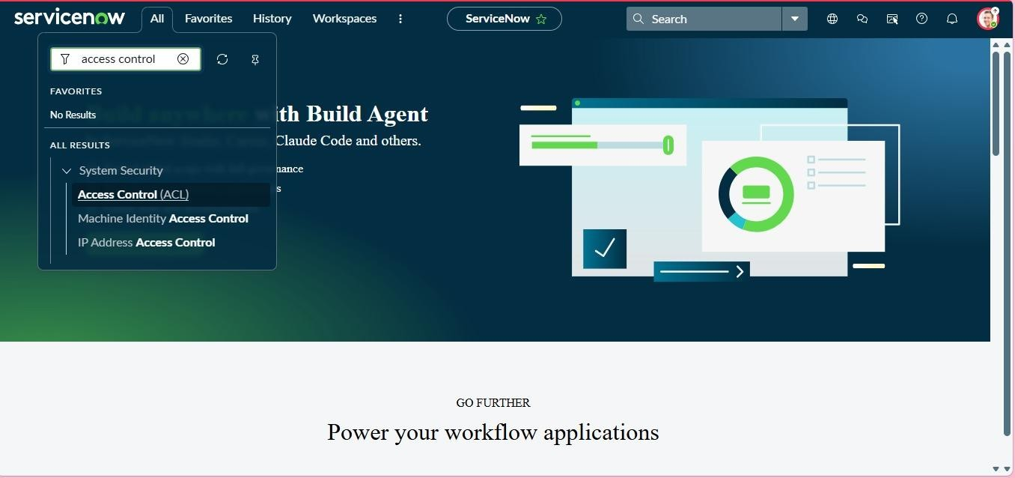

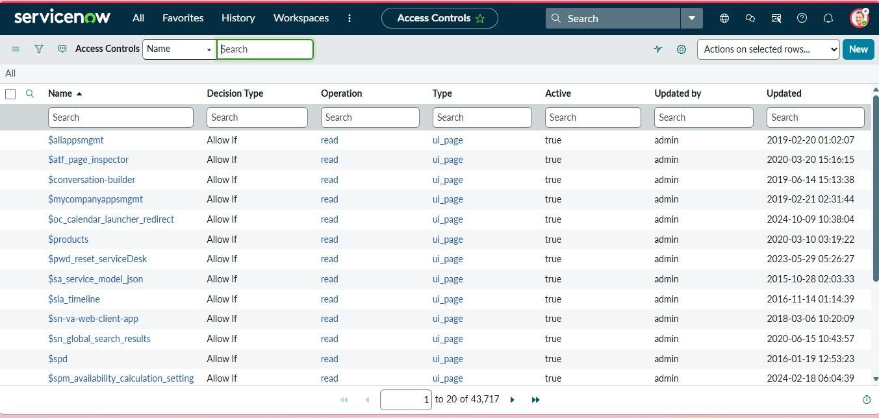
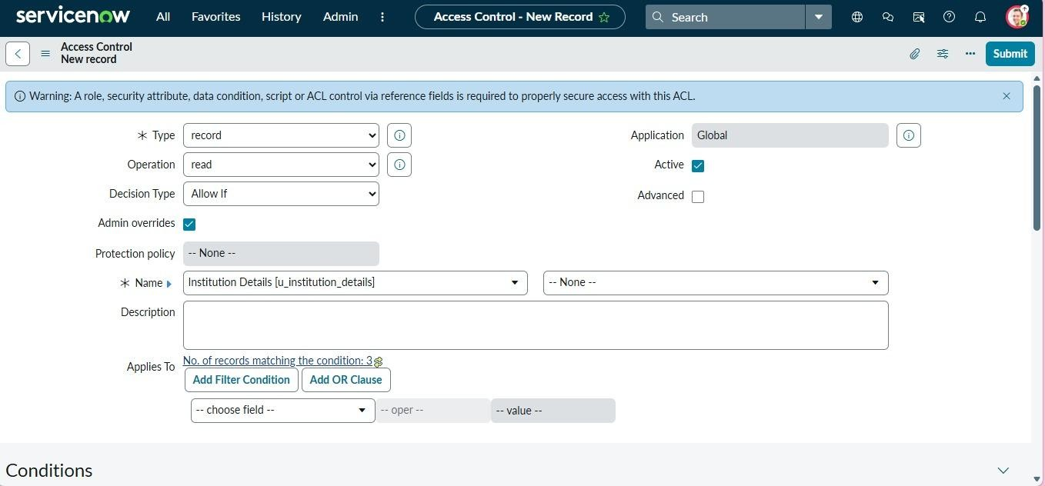

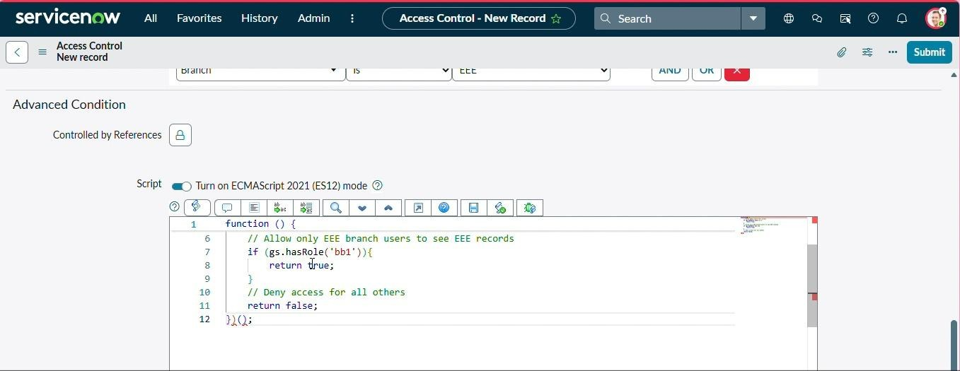

- Impersonate EEE users and open the Student Records list.
- Copy the table name u_institution_details.list/LIST and paste in the All menu.
- Impersonate Admin and open the Student Records list. Verify :
- User with bb1 role can view only EEE branch records
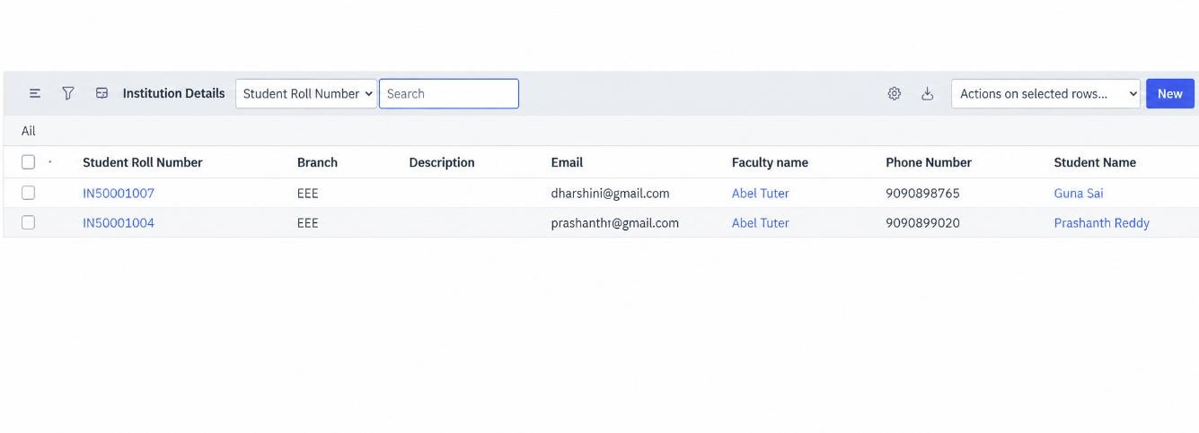
- User without the role cannot view any records
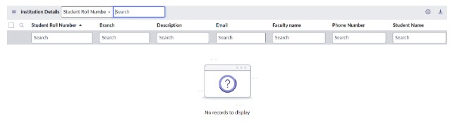

- Admin user can view all records regardless of branch
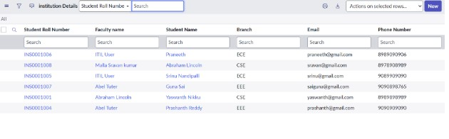

Creation of Access Control Lists(Create ACL)
1. Click New to create a new ACL(Create) 2. Enter the following details:
o Type: record o Operation: create o Name: u_institution_details o Active: true
- In the Requires role related list, add:
o bb2 (custom role)
- No need to add any Data condition
- Save the ACL Record

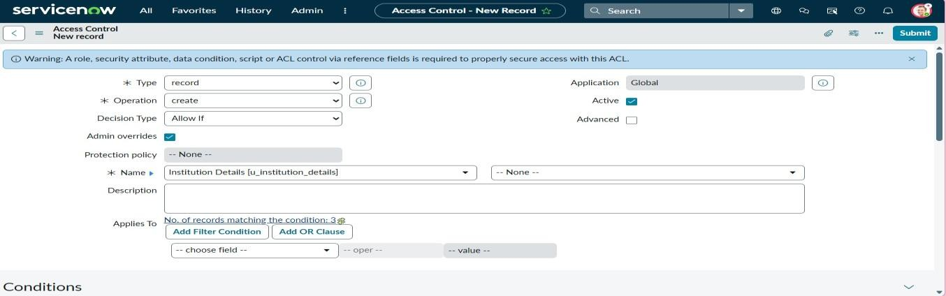
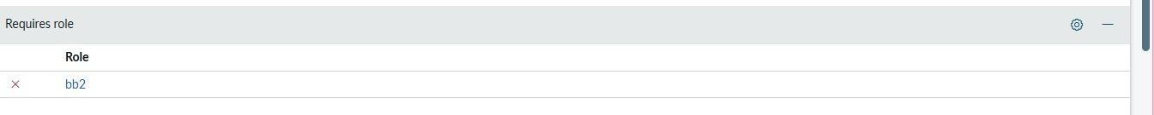
Verify :
• User with bb1 &bb2 roles can view only EEE branch records b New Button

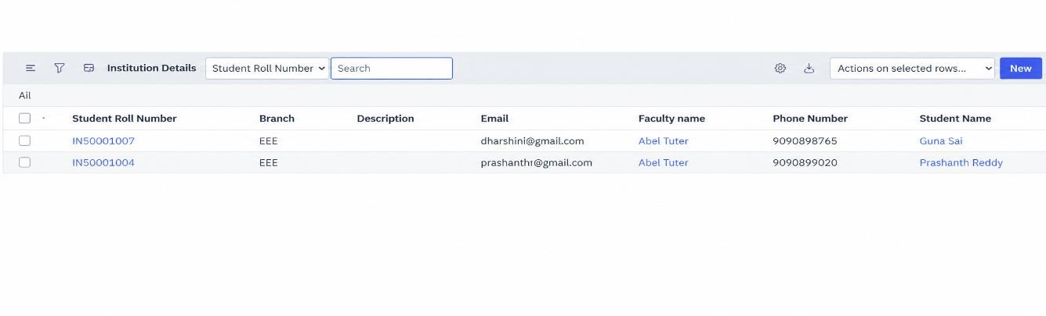

Creation of Access Control Lists(Write ACL)
1. Click New to create a new ACL(Write) 2. Enter the following details:
o Type: record o Operation: Write o Name: u_institution_details o Active: true
- In the Requires role related list, add:
o bb3 (custom role)
- No need to add any Data condition
- Save the ACL Record

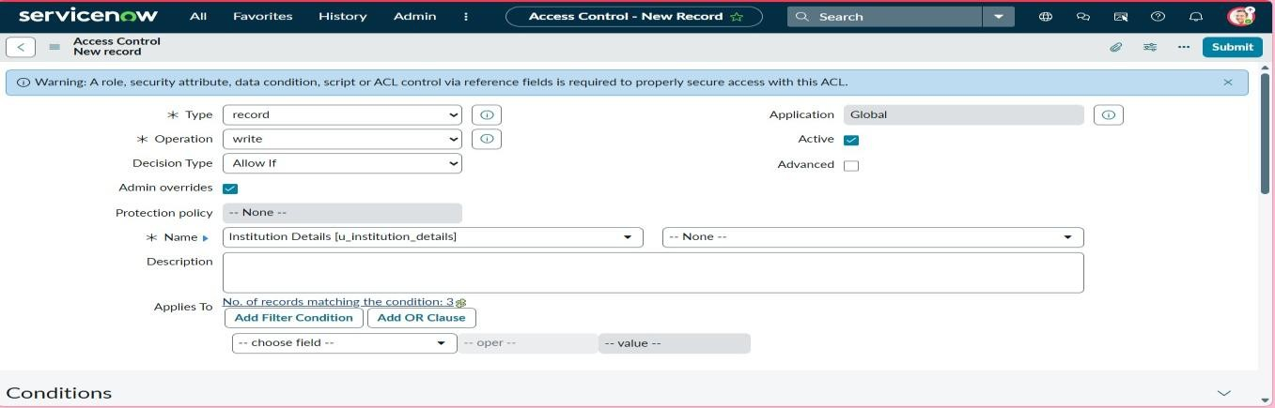
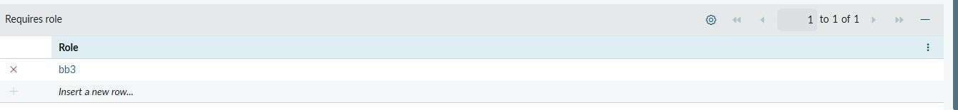
Verify :
• User with bb1 &bb2 &bb3 roles can view and edit the EEE branch records along with New Button
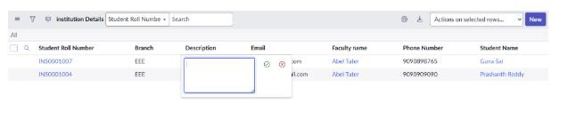

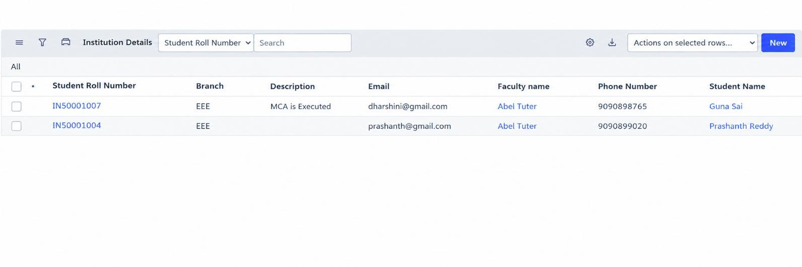

Creation of Access Control Lists(Delete ACL)
1. Click New to create a new ACL(Delete) 2. Enter the following details: o Type: record o Operation: Delete o Name: u_institution_details o Active: true
- In the Requires role related list, add:
o bb4 (custom role)
- No need to add any Data condition
- Save the ACL Record

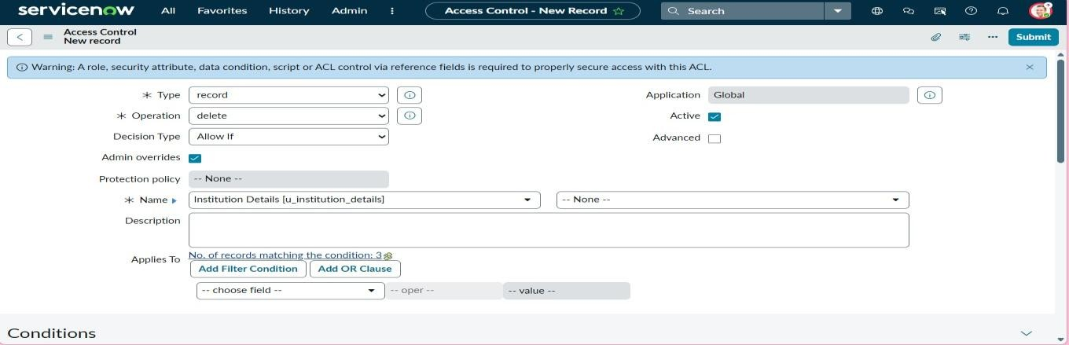
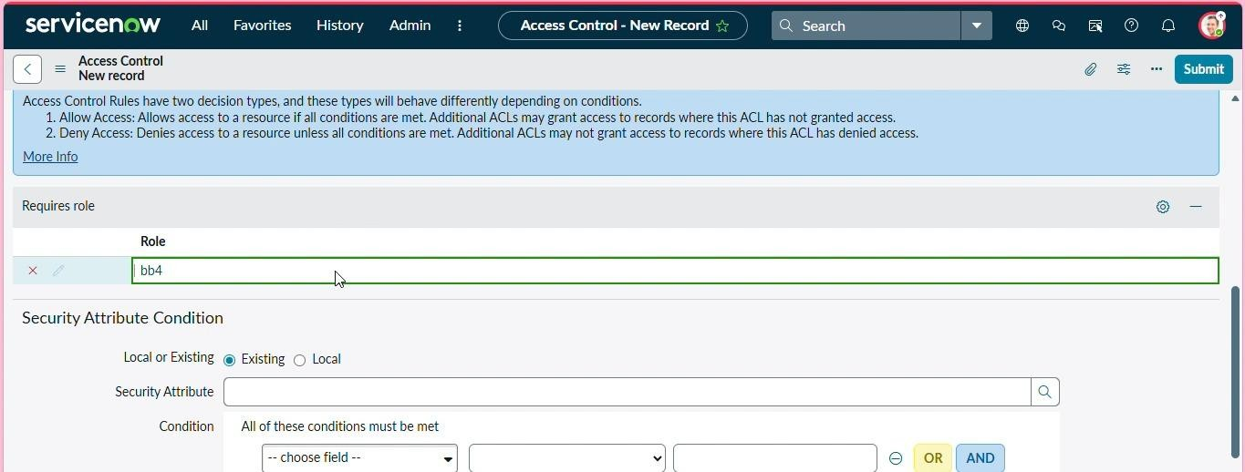
Verify :
• Users with bb1 &bb2 &bb3&bb4 roles can see, create and edit along with delete the EEE branch records.
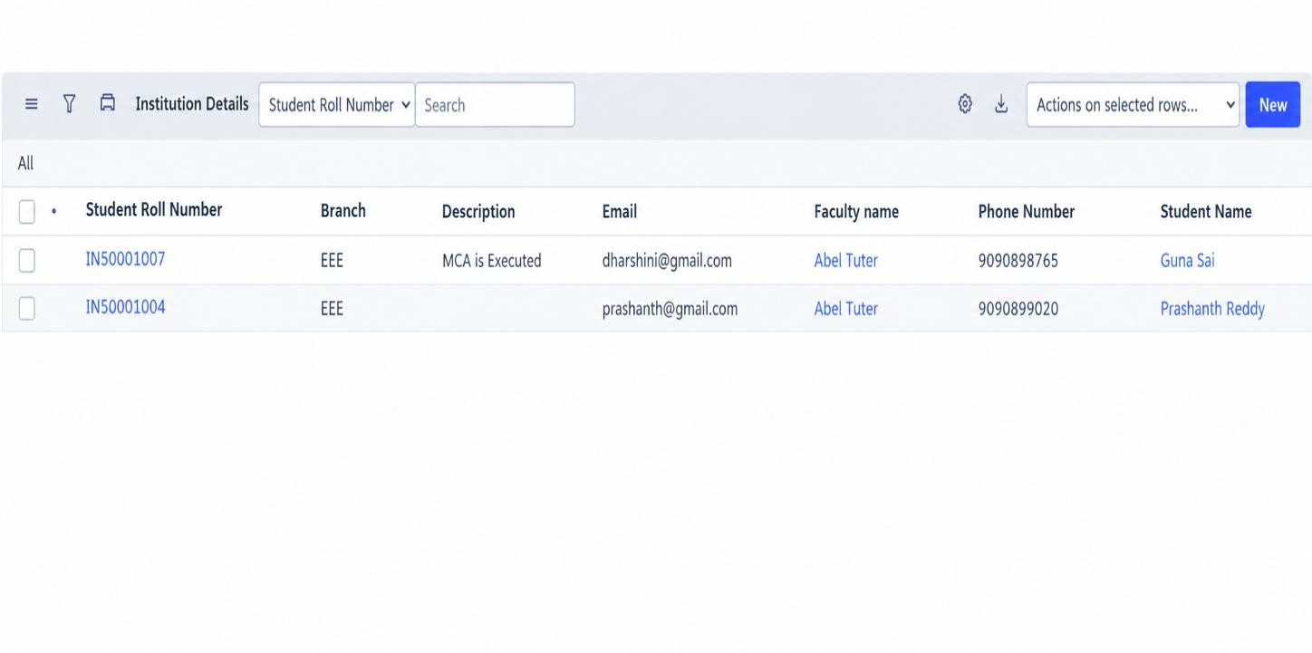
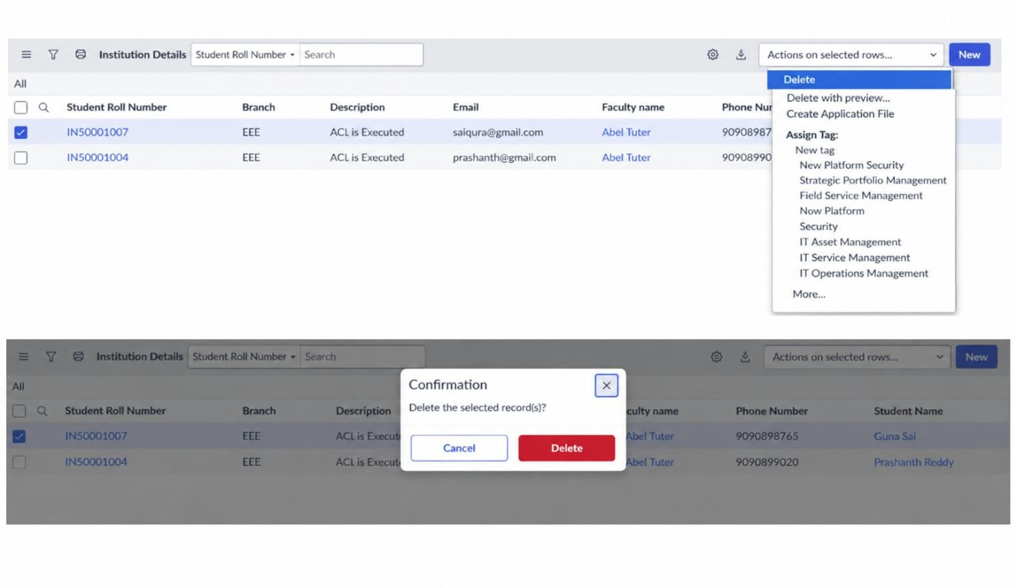
Outcome :
By completing this lab, learners gain a comprehensive understanding of how scriptcontrolled READ, WRITE, CREATE, and DELETE ACLs enforce record-level security, how user roles and record field values are evaluated together to make access decisions, and how ACLs protect sensitive data from unauthorized viewing, modification, creation, and deletion across forms, lists, and Service Portal interfaces.

Advantages
- Provides secure record-level access in ServiceNow.
- Allows access based on user roles and field values.
- Protects sensitive student information from unauthorized users.
- Supports READ, CREATE, WRITE, and DELETE access control.
- Administrators can retain full access to all records.
- Helps prevent unauthorized viewing, editing, and deletion of records.
Disadvantages
- Creating and managing multiple ACLs can be complex.
- Incorrect scripts or role settings may prevent authorized users from accessing records.
- Requires proper knowledge of ServiceNow security and ACL configuration.
- Managing many custom roles can increase administration work.
- Changes in branch or user requirements may require updating the ACL configuration.
Future Enhancement
In the future, the Script-Controlled ACL system can be enhanced with more flexible and advanced access control features. Access permissions can be extended to different branches, departments, and user categories. Dynamic conditions can be introduced based on fields such as department, year, designation, or user role. The system can also include detailed access logs and monitoring features to track user activities. Automated testing can be implemented to verify ACL permissions whenever changes are made. In addition, the ACL system can be integrated with other ServiceNow applications and workflows to provide centralized and efficient security management. These enhancements can make the system more flexible, scalable, and easier to manage.
Conclusion
The Script-Controlled ACL provides an effective way to control access to records in ServiceNow. It combines user roles and field values to determine whether a user can view, create, modify, or delete records. In this project, access to EEE branch records is controlled using different roles and ACLs. This helps protect sensitive information and prevents unauthorized access. Overall, the project provides a practical understanding of record-level security and demonstrates how ACLs can be used to improve data protection in ServiceNow.

